The first effort to provide a glimpse of, then Landstuhl AB, to the local population came on 10 March 1953. The intent was to showcase the result of the construction that began in January 1952 to prepare the base for occupancy and operation. Col Bickell, the 86 FW Commander, also sought to demonstrate the determination of the community of Western Nations and the positive action they had taken ·to defend the free nations against aggression. Moreover, he believed that the citizens of West Germany would only be able to make the decisions that best served their interests if they were armed with the facts to do so. To this end he invited the representatives of major and respected news media in Germany to come to Landstuhl to learn about the facilities and to subsequently inform the West German people about what they had seen. (Illustration 1 & 2).

This early effort to achieve transparency led to the Open House/Flugtag in 1955. This enabled a few thousand visitors to get their first glimpse of American aircraft and ground equipment. This event, like the media day in 1953, was originally designed to increase public understanding of the Air Force mission and display the spirit of mutual cooperation among allied nations. The annual air show grew to become the largest and most effective means of promoting community relations within the Federal Republic of Germany as well as throughout Western Europe. At the 1956 Open House there was also a sports car race, soccer game and performance by the USAFE aerial demonstration team, the Skyblazers. Beginning in 1973 the Open House became known as FlugTag. It proved to be so popular that by 1976 the crowd reached 600,000.

The 1981 Flug Tag peaked at 700,000. In 1987, the weather was not cooperative and some aerial events were cancelled. Still, on that cool and rainy day some 250,000 guests showed up. In the aftermath of the ’87 show the new Flugtag committee began to formulate plans for yet a bigger and better show in the summer of 1988. By this time Flug Tag had become a tradition spaning more than 25 years during which organizers had invited NATO nations to participate in aerial activities, to provide static displays, and to have national Aerobatic teams from NATO air forces fly their programs in these shows. Flugtag proponents sought to provide an open house setting which displayed the equipment and capabilities of the allied air forces to enhance public understanding, awareness, and acceptance for the mission of NATO air power.

Planning for the ’88 event went beyond earlier preparations for this event due to growing public opposition to the air show. This resulted in the inclusion of extra security and safety measures, such as close coordination with German medical and fire officials, which included arrangements for reserve response forces in six villages surrounding the base. These stand-by personnel served as the immediate backup for more than 1,280 police, 56 firefighters, and 36 medical personnel that were dispersed to nine locations on and around the flight line area along with 12 fire/rescue vehicles, 15 ambulances, and five helicopters that went on alert before the crowds began to arrive. Imagine the magnitude of the disaster had there been less personnel to attend to the critically injured?

It was almost a picture- perfect day at Ramstein AB as the weather cooperated with well constructed plans and preparations that included a contained spectator area more than 1520 feet away from the center of the air show area and exceeded all US and NATO requirements for events that involved flying demonstrations in the program. Even the aerial demonstrations progressed on schedule right up to the takeoff of the last aerobatic team on the day's flying schedule, Italy ' s Frecce Tricolori flying MB-339A jets. Practically everyone in the crowd watched with bated breath as this ten-member team completed its initial movements and began an intricate "Pierced Heart" maneuver where team elements would cross each other from three different directions with the team soloist looping in the middle and quickly climbing out in front of the crowd well within the designated air show area (see illustration 3). A hushed silence prevailed over the entire area right through the moment that three of the Italian aircraft collided at 1546 in the afternoon. This crash resulted in a series of events that were later described as one of the greatest disasters in air show history, the worst of these followed the impact of the solo aircraft immediately in front of .the then densely-populated spectator area. Fire-fighting equipment and medical personnel were on the scene within seconds and the first helicopter was airborne only four minutes after the aircraft exploded. All three aircraft fires were under control in seven minutes and put out in 13 minutes. while the Explosive Ordnance Disposal personnel secured all six ejection seats from the Italian aircraft, but the greater damage was already done.

Spectators stood in shock as security, medical, and fire-fighting personnel rushed to the aid of those injured by flying debris or a wave of jet fuel that passed over the crowd creating a total of 500 victims that were treated by various medical facilities within 24 hours of the accident. A total of 34 fatalities (31 spectators and the three Italian pilots) resulted from the initial impact and about 169 seriously injured cases were evacuated by 18 American, British, and German helicopters within 77 minutes after the crash, leaving those with less serious injuries to
be moved by motor vehicles that also completed all initial response runs within 96 minutes after recovery operations began. Of the 500 patients identified at the crash site, over 300 were treated and released in a 24-hour period which left a total of about 200 victims that were either unidentified casualties or patients admitted to a string of some 50 medical facilities that stretched from West Germany to the United Kingdom. Criticism by German politicians and medical officials not involved in the rescue efforts came almost as quick as the hundreds of volunteers from the crowd who moved in to immediately help every wounded person in sight regardless of their condition, but neither side could do much to stop the death count that continued to rise on almost a daily basis. Some of these volunteers quickly moved to establish a casualty information center manned by military and civilian personnel alike for 24 hours a day until hundreds of daily inquiries were answered and all the missing were accounted for about a week later. There was no doubt that these unsung heroes saved more than a few lives on what became a day of infamy for Ramstein AB when the number of fatalities reached a total of 70 and included four Americans along with the 6 foreign nationals. At the time is was said that it would take a long time for wounds to heal as far as German American relations and disputes over future flight operations were concerned. Nonetheless, General Boese was extremely proud of the humanity shown by community members during recovery from an event that would be clearly remembered for all the wrong reasons. Moreover it served as the catalyst which turned German public opinion against low-level flying such as the type that took place during Flug Tag.

A joint American-Italian-German commission, under the direction of the German Federal Armed Forces Director of Flight Safety, investigated the accident and concluded that human error, that is, misjudgment on the part of the solo pilot, caused the accident. Years later the base attempted to revive the tradition of the Open House, though, without aerial events. On 1 October 1995 the base saw a much smaller crowd (22,000) attending the Air Base Open House or Air Base Festival with displays from several countries as well as local USAF & US Army equipment. There was no Open House on base in 1996. In 1997 the open house was resumed, though it was held from 4-6 July and called “Freedom Fest.” In 1999 and 2000 it was held from 2-4 July and drew approximately 32,000 visitors each year.

The upshot is that while aerial demonstration ceased after 1988, the Base sought to maintain the Open House tradition, even if only for a few years during the latter half of the 1990s. Recent events such as 9/11 have mitigated against hosting such large events at Ramstein.

SCHEDUL OF EVE NTS FOR 10 MARCH 1953

Time EVENT

0930 hours | Bus to meet correspondents at Main Railroad Station in Kaiserslautern. Staff car to call for French Delegue at his office in Kaiserslautern.
1030 hours | Group to assemble at Wing Commanders Office for welcome and posing pictures.
1045 hours | To assembly room for speech by Capt Hopman on behalf of Col Bickell.
1110 hours | Tour of base via bus to include stop at dog kennels and other points of interest (Tower, etc)
1140 hours | Visit to exhibit arranged by Fighter-Bomber Group.
1220 hours | To Officers Lounge for refreshments.
1240 hours | To Officers Dining Room for Luncheon.
1330 hours | Open press conference at table in Officers Dining  Room, with ·Wing Commander and members of staff .
1400 hours | Depart. Bus to be available to return correspondent s to Kaiserslautern and Staff Car for French Deleeue.

Illustration 1
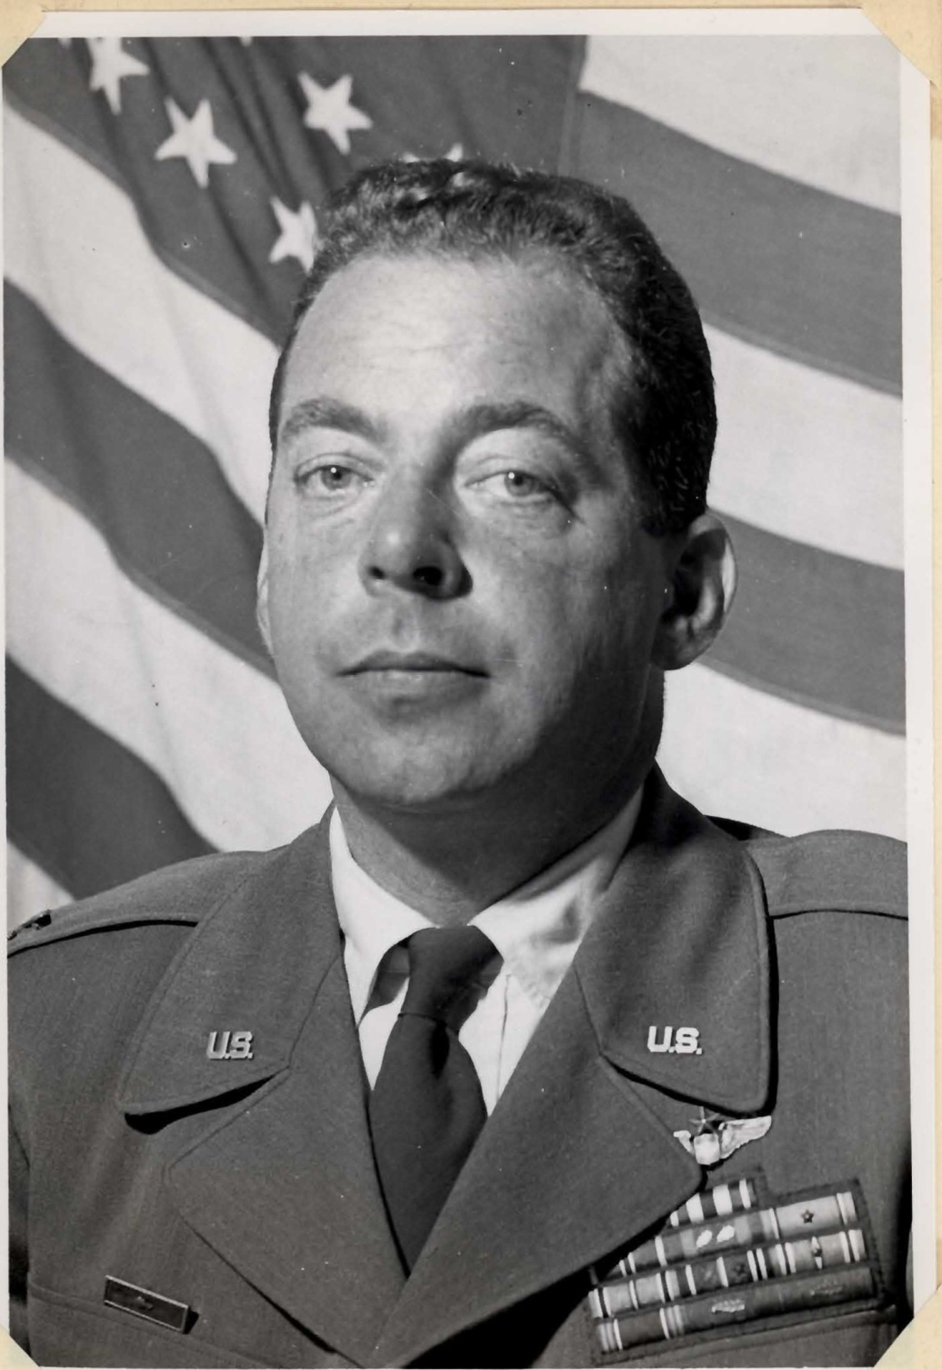

COLONEL GEORGE R. BICKELL
Commanding Officer, 86th Fighter-Bomber Wing

Illustration 2

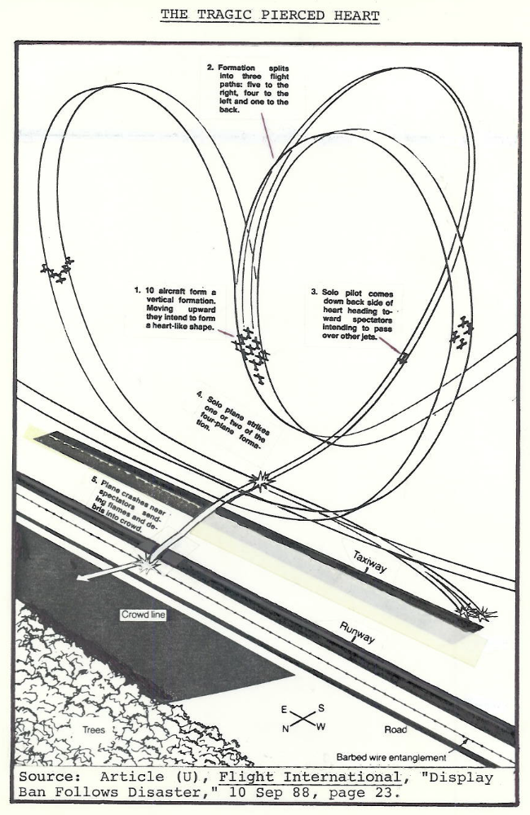
Illustration 3

