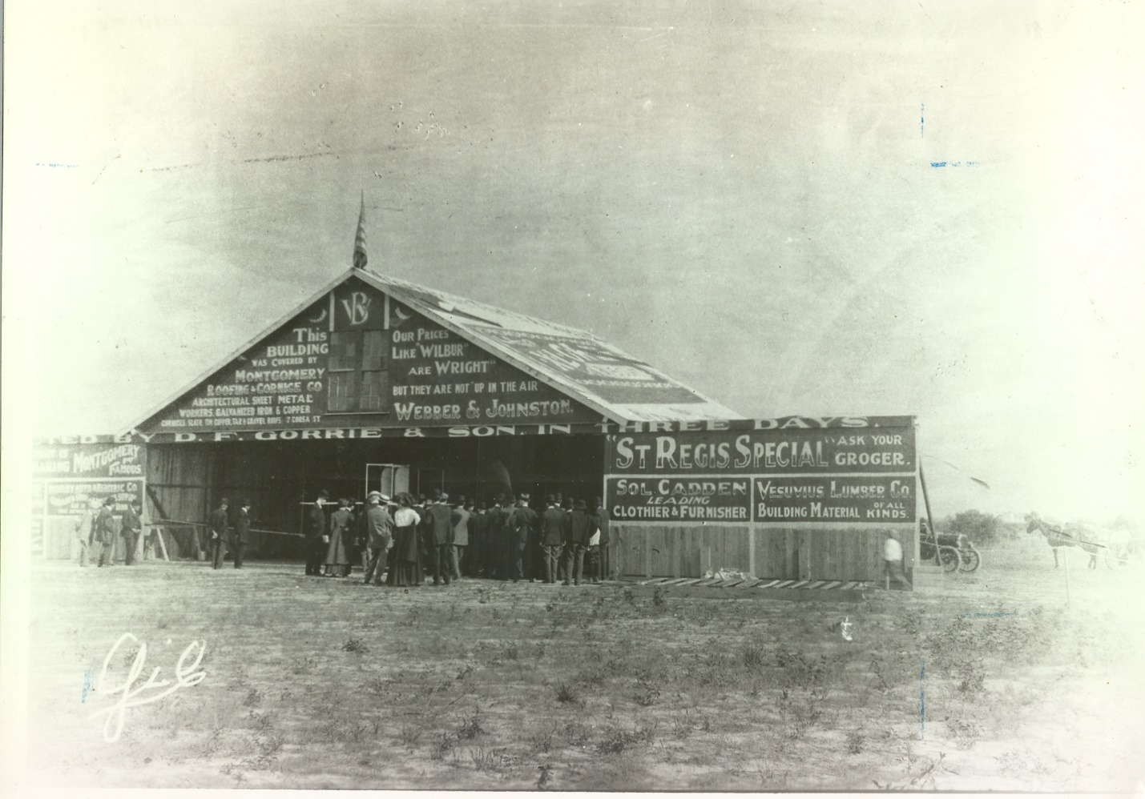

Maxwell

100 Years of Distinguished Service

By

Dr. Silvano Wueschner

Air University Office of History

Boll Weevil

In the early 1920s, the Mexican boll weevil began migrating into Texas and soon began spreading across the southeastern portion of the United States. The U.S Department of Agriculture established a research laboratory, in the Mississippi Delta region at Tallulah, Louisiana, and soon developed a pesticide that controlled this pest. The problem was how to effectively and efficiently spread the powder over thousands of acres of cotton fields. In 1923, Delta Lab officials came up with the idea of using airplanes to apply the chemical. They obtained two planes, two pilots, and a mechanic from Maxwell to assist in this experiment. An iron hopper was constructed and fitted inside the observer’s cockpit, the powder was sifted through the outlet tube that projected through the bottom of the fuselage. The plane flew from 5 to 15 feet from the ground at about 85 mph, the air current created by the whirling plane propeller blew the dust downward and outward onto the cotton plants below.

Aerial application process proved to be a highly effective technique. In a normal three mile sweep a plane could discharge its cargo over a strip 150 feet wide. Moreover, it could cover an area in two minutes that it took five people on the ground to cover in over 2 hours, and required only two pounds of powder per acre as compared to the nearly six pounds per acre required for ground application.

The case can be made that Maxwell pilot's contribution to treating boll weevil infested fields from the air was a determining factor in the success of experiments in Tallulah. Tests proved beyond a doubt that aerial dusting was feasible. This, then, led the Huff-Daland Company to design an aircraft specifically for that purpose. In 1925 a dusting subsidiary was incorporated and briefly based in Macon, Georgia. It was later permanently relocated to Monroe, Louisiana. Huff Daland Dusters, Inc., was incorporated in 1925 and was the first aerial crop dusting company, which in 1928 became Delta Air Service.

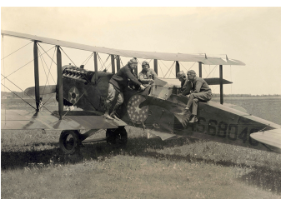
22nd Observation Squadron, Maxwell Field Pilots at Tallulah, Louisiana

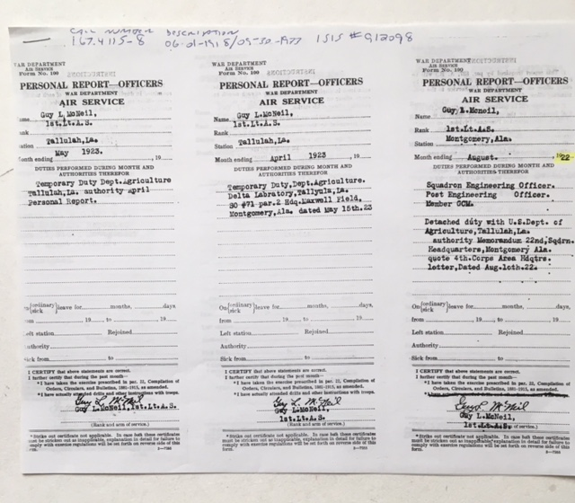
1st Lt. Guy L. McNeil’s orders detailing him to the U.S. Department of Agriculture at Tallulah, Louisiana.

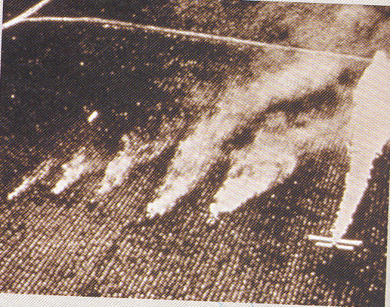

Crop Dusting Cotton Fields

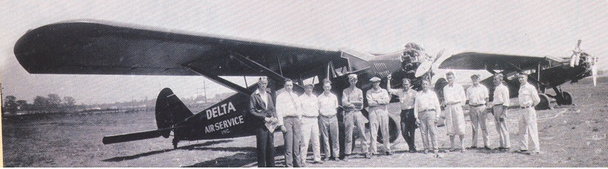

Delta Air Service Personnel

DELIVERING THE MAIL

The 22 Observation Squadron at Maxwell helped to determine the viability of establishing an airmail route between the Gulf Coast and northern Great Lakes area. The route included stations in New Orleans, LA; Mobile, AL; Birmingham, AL; Nashville, TN; Indianapolis, IN; and Chicago, Il. The experiment was designed to see if mail could be flown on a daily basis from New Orleans via intermediate points to Chicago in time to make connections with the regular westward and eastward transcontinental airmail service. The expectation was that, if successful, service time for mail from the south destined for the Atlantic and Pacific coasts would be reduced by several–days. Moreover it would set the stage for the establishment of a permanent airmail service in the region.

The trial flight was sanctioned by U.S. Post Master General, Paul Henderson in a telegram on 16 April 1925 which stated "You are authorized to send specifically addressed mail by plane scheduled by test flight via New Orleans and intermediate points to Chicago or Cleveland. Any mail intended for connection with transcontinental airmail must bear necessary airmail postage and the pilot in charge must be a sworn mail carrier." Lt Robert D. Knapp and his mechanic Sgt J.A Liner left Maxwell at 1100 that morning in a DeHaviland (DH) 4Bs, powered by a 420-horsepower Liberty engine and traveling at nearly 110 miles-per-hour. They traveled the 321 miles to New Orleans in only 2 hours and 40 minutes. Upon their arrival at Peters Field they were greeted by a welcoming committee and subsequently sworn in as mail carriers.

At 0530 the next morning, Lieutenant Knapp and Sergeant Liner took off on the first leg of the journey, carrying six bags of mail destined for Mobile and numerous cities throughout the country. They arrived in Mobile at 0645and remained long enough to pick up more mail. By 0700, the crew, along with five additional bags of mail, was airborne and headed for Maxwell field. They arrived at 0820 to a roar of cheers from civilian dignitaries and military officials gathered at Maxwell Field in anxious anticipation of a pending historical event. The dignitaries included Congressman Lister Hill, Governor William W. Brandon, Commissioner William J. Drum, Adjutant General Hartley E. Moon, and Major Roy Brown, the Commander of Maxwell. Montgomery Postmaster Roy F. Lifsey was also present and later swore in Captains Asa N. Duncan and J. A. Simpson as mail carriers. The latter two had arrived earlier DH-4 from Birmingham. They were scheduled to fly the second leg of the test flight to points north.

Montgomery mail destined for several northern cities was waiting at Maxwell. Potential customers were told that "mail intended for the air service on the first flight Friday must be in the post office by 8 o'clock Friday morning," and "Letters must be indorsed By Air Mail Service and must carry the proper postage." The postage, depending on its destination, ranged from 8 to 24 cents. At 0842, 18 minutes ahead of schedule, the DH-4 piloted by Captain Duncan took off for to Birmingham where he picked up additional mail before heading on to Nashville. In Nashville the mail was transferred to a plane, manned by Lt Vincent J. Meloy and Capt Herbert Fox destined for Louisville, Indianapolis, and Chicago. The flight took off around 1201 in a drizzling rain. The DH-4 was not designed to fly in this kind of weather, still, Lieutenant Meloy flew his plane through a driving rain on to Louisville and Chicago. Lt Meloy chose to bypass Indianapolis and arrived in Chicago at 1620, in ample time to connect with the transcontinental airmail service.

Registered mail valued at over $3 million had been transported to the "Windy City" in the record breaking time of less than 12 hours. Post office authorities and airmail officials, who observed each stage of the test flight, ruled it an unqualified success. Once again Maxwell contributed another chapter to the annals of aviation history. Not only had local field personnel flown the initial leg of the trial test, they were also largely responsible for the development and execution of the entire plan. According to Senator Hill, "the perfect manner in which all arrangements were carried out by the officers at Maxwell Field and by Postmaster Lifsey and the maintaining of the schedule by the airmen would probably have considerable effect in obtaining the permanent air service at an early date."
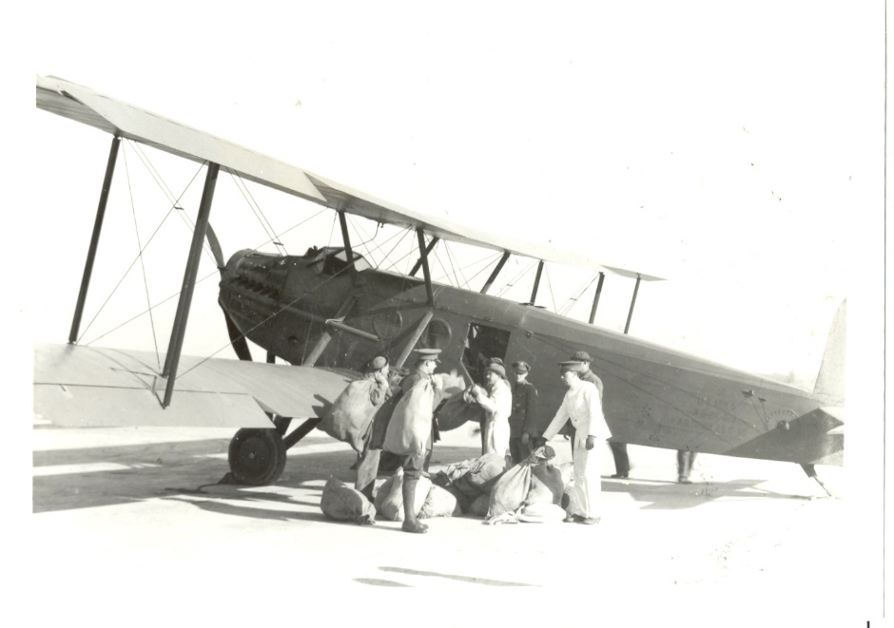
Mail being loaded on Maxwell Field Aircraft

Maxwell Field Flier Established A New Record 30 August 1929 On Hop From Dayton Ohio to Maxwell Field

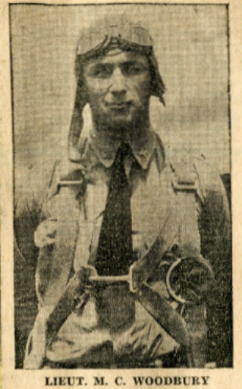

Whisking through the air from Dayton, Ohio, at a speed averaging more than two miles a minute, Lieut. Murray C. Woodbury landed at Maxwell Field yesterday in four hours and 20 minutes (flying time), thus establishing a now time record for observation type airplanes. Leaving Dayton before noon, Eastern time, he flew to Nashville in two hours and 15 minutes. After refueling there he flew to Montgomery in two hours and five minutes. The air distance from Dayton to Montgomery is about 575 miles. He was aided in establishing a new record because of strong "tail winds" he reported.

The aviator, who has been with the Twenty-Second Observation Squadron since coming here from Jacksonville more than a year ago, used a Douglas 02-H biplane, equipped with a Libertv motor. While it was not learned how much the old record was beaten it is understood that many minutes were clipped from any known speed record for observation planes. Lieut. Woodbury had been to the national air races at Cleveland and was bringing an airplane here from Fairfield, Ohio. (from the Montgomery Advertiser August 1929)

Three Men on the Flying Trapeze

The "Three Men on the Flying Trapeze" aerobatic display team was organized at the US Air Corps Tactical School at Maxwell Field, Alabama in 1932. The team flew P-12 pursuit planes. The aerobatic team was formed by ex-"Three Musketeers" member Capt. Claire L. Chennault and was finally disbanded in 1936 when most of the pilots went to China and served with the Flying Tigers.

Captain Claire L. Chennault had used a simple method to choose the team. Anyone who could fly with him in his P-12 for 30 minutes of head-spinning aerobatics would be selected. Although many tried, only Lt Haywood S. "Possum" Hansell, Sgt John H. Williamson, and Sgt William C. McDonald accomplished this feat and were consequently selected by Chennault to join the team.
A trophy was presented to the team during the All-American Air Races at Miami, Florida in 1935.

During the four years of the "Three Men on the Flying Trapeze" team's existence, they performed in approximately 50 airshows in front of more than 50,000 people.

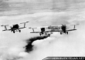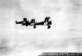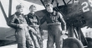

Skylarks

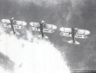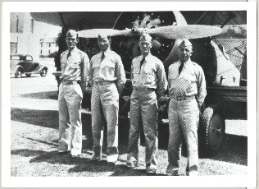

The "Skylarks" aerobatic team from US Army Air Corps at Maxwell Field, Alabama, was created in 1935 once again under the mentoring of Captain Claire L. Chennault who had been the creator and leader of the "Three Men on a Flying Trapeze" aerobatic display team from the same airbase. A major event in the team's history were the displays at the National Air Races at Cleveland, Ohio, in September 1937.

The team's display included tight formation flying, loops in formation, barrel rolls, spins, Immelmans, a double formation roll, an inverted flight formation, and a snap roll from the top of a loop. The team's pilots were Capt. Charles D. McAllister as leader, Lt. Wilbur W. Aring, Lt. Carl D. Storrie and Lt. Clayton E. Hughes. They flew three Boeing P-12E pursuit fighters and were eventually disbanded at the end of 1937 due to personnel reassignments.

1944 Maxwell Field Open House, 1 August 1944
Aerial Pageant To Crowd Sky 0ver Maxwell
Two Dozen Liberators To Fly Formations For Visitors
(Montgomery Advertiser 30 July 1944)

Aerial pageantry, highlighted by a formation of 24 Liberator bombers, will be the order of the day Tuesday a t the Maxwel1 Field "Open House" celebrating the 37th anniversary of the greatest flying team ever airborne - the United States Army Air Forces.

Jointly observed will be the 35th anniversary of the purchase of the first military airplane. The scope of the program became evident yesterday, when Col. R.E L. Choate, Maxwell Field commanding officer", approved final plans for the Open House.

Visitors will be able to observe large formations of the Liberators in the sky during the Open House, inasmuch as formation flying is part of the curriculum of the four-engine transition school al Maxwell Field. Prior to the completion of individual training missions, all aircraft assemble at a predesignated point and time, and practice formation flying, prior to landing. During these practice formations periods, the leader of each flight leads his formation over Maxwell Field, where it is I reviewed by supervisory personnel on the ground. The formations are checked for spacing and accuracy. One of these formation periods has been set for 4 p.m., and will be seen as curtain-raiser to the parade of the entire corps of aviation of the AAF Pre-Flight School at 5 o’clock

No Passes Needed

No passes will be demanded of case visitors expected to flock to the base to witness a program lasting from 1:30 to 6 p.m. Programs, including a map of the field, showing the parking and display area, will be given those attending.

By removing the wraps from what is perhaps one of the largest bases in the AAF Training Command, Alabamians will have
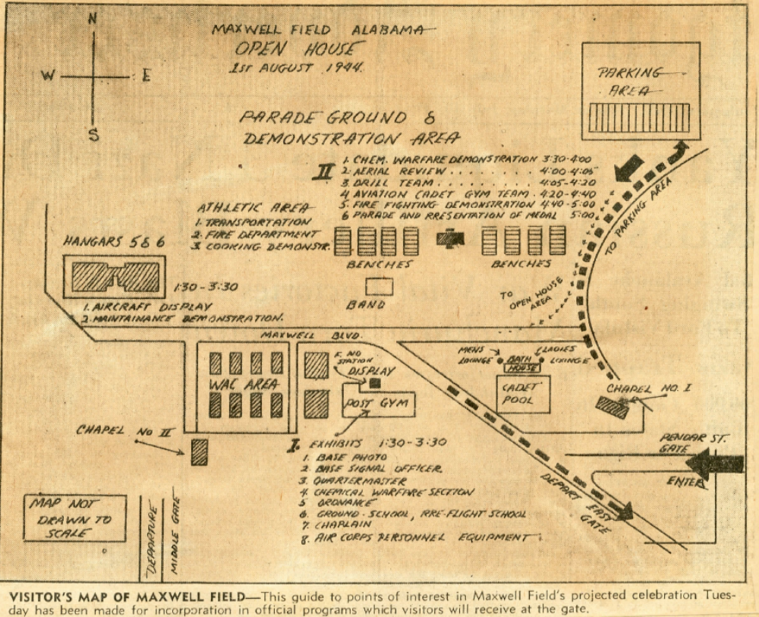

Service to the Civilian Community During Times of Distress

The 1929 South Alabama Flood

Maxwell has also distinguished itself for its service to the civilian community during times of distress. At 9:00 P. M., Thursday, March 14th, 1929, Governor Bibb Graves, of the State of Alabama, telephoned to the .Commanding Officer, Maxwell Field, and requested that the United States Army Air Corps render assistance to the population of South Alabama, that reports had been received to the effect that several towns and villages were inundated and all communication severed, highways and railroads in the affected area washed away, as a result of excessive Spring rains. The Commanding Officer assured Governor Graves that every resource of the station would be used and all possible assistance rendered.

Thereupon, “Officers' Call"’ was caused to be sounded at 9:15 P.M., for the purpose of assembling all post officers in Headquarters for instruction in connection with relief work commencing at daylight on the morning of March 15th.

"Call to Arms" was also sounded and the 22nd Observation Squadron and 4th Photo Section, less the engineering and flight sections, stood by ready with full field equipment for departure over-land to the flooded area. They were not sent forward as the first reconnaissance mission executed by airplanes reported that the National Guard of Alabama would be able to cope with the situation, except in supplying food, clothing, and medical supplies.

Realizing that the people were not familiar with the Army Air Corps-Red Cross Message Code, the Montgomery Advertiser, the morning newspaper of Montgomery, Alabama, was requested to carry a special edition of the air-ground message code in their issue of March 15th, 1929. The Montgomery Advertiser delivered a supply of the special editions to Maxwell Field and they were dropped to all towns and villages effected by the high waters. With the exception of radio communication with the Squadron Radio Field Truck, six miles north of Elba, Alabama, and a few phone messages relayed from towns of some distance from the flood, the air-ground message code was utilized as the sole means of communication with relief parties throughout the period of relief work.

Maxwell Pilots flew dawn to dusk air drop missions for 5 days to deliver food and supplies to residents of Montgomery and southern Alabama communities. Between 14 and 20 March Pilots delivered Air-27112 Tons. They accomplished this using 40 planes (some coming from as far away as Langley Va.) flew 346 sorties, totaling 644 Hrs and 10 minutes, and covered approximately 60,000 miles. This marked the first time food and supplies were airdropped by the U.S. military during a major civilian emergency.

From the minute the officers of the Post were called together by Major Weaver,
until our work was no longer necessary, the Post was on a "war" basis. Routine duties became things to be accomplished after all else was finished. Officers with responsible Post jobs accomplished their six to eight hours in the air for the relief of flood sufferers, came in, grabbed a bite to eat and went to their desks to bring routine duties up to date. It was the rule rather than the exception to see officers working· night after night to accomplish their regular work after a hard day in the air. Little time was allowed for meals during the daylight hours. Consequently lunch with hot coffee was prepared by the ladies of the Post under the direction of Mrs. W. R. Weaver and was available to the pilots, throughout the day. Usually a period of only fifteen minutes was necessary to service a plane after a mission before the plane and its crew would speed south again on their errand of mercy. Some of the quotations from the press are of special interest in connection with this work:

South Alabama's flood presents for the first time in the history of the United States the most complete system of relief work demonstrating efficiency of the airplane and trained aerial observer in carrying assistance quickly to distressed thousands in an area which otherwise would be almost inaccessible perhaps for days. While it is possible to record activities of those men from Maxwell Field engaged in this relief, neither pen nor tongue of the thousands of beneficiaries in flooded districts at Geneva .. Elba, Brewton, Samson, Pollard, Flomaton and Keego adequately could express the gratitude of sufferers, many of whom owe their lives to the speed and dispatch with which their needs have been supplied.

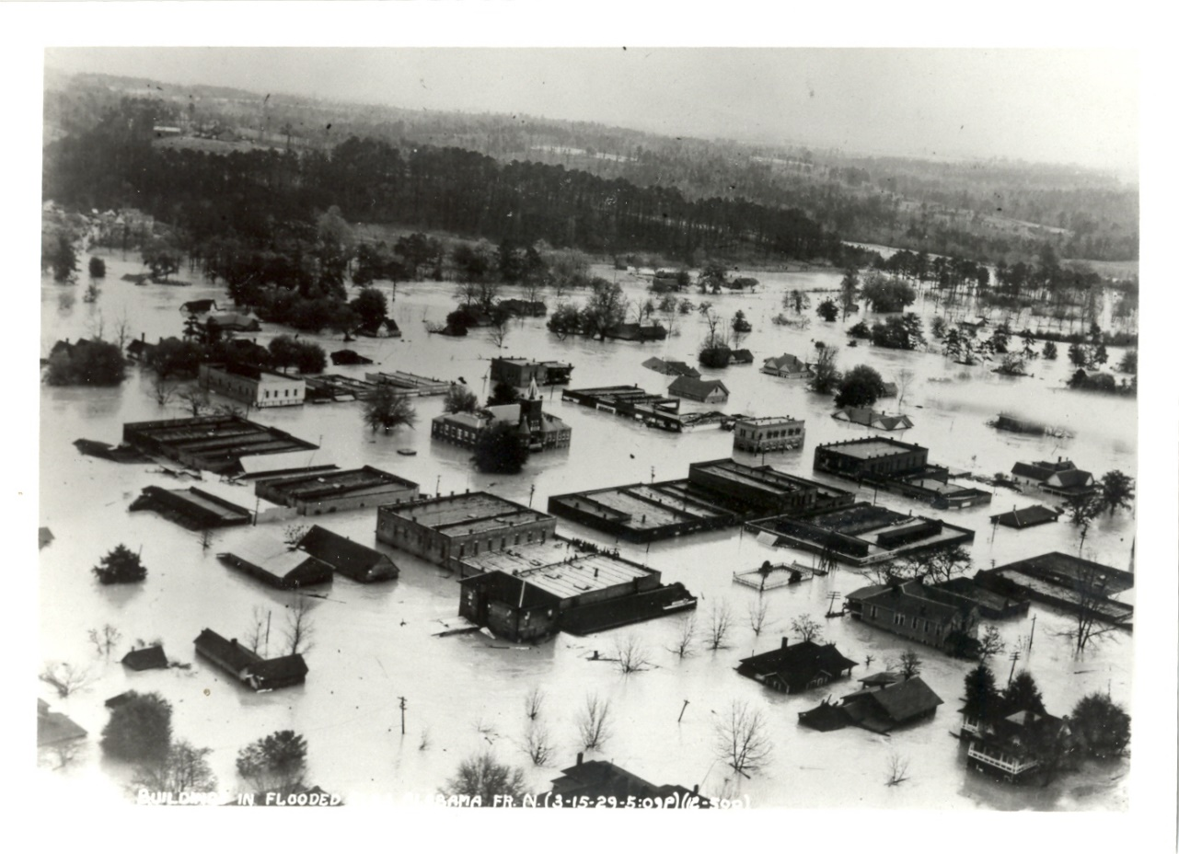
15 March 1929 Elba, Alabama

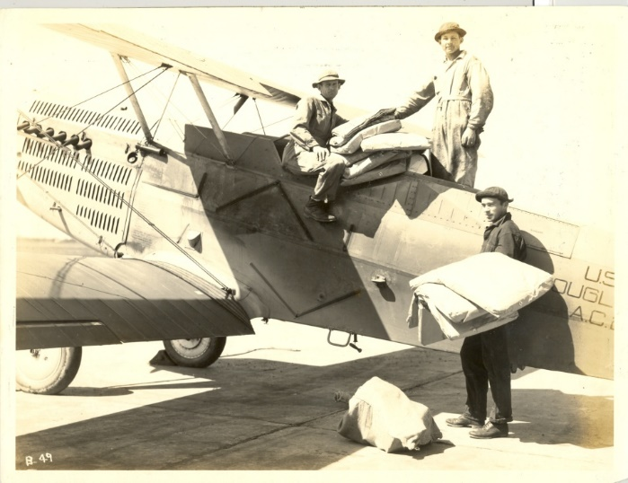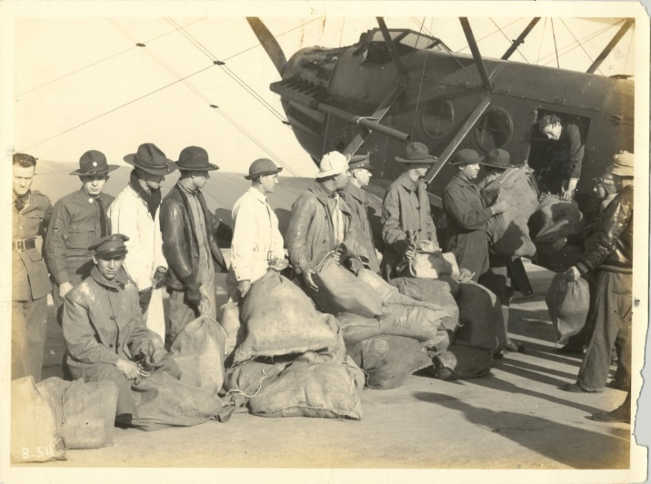
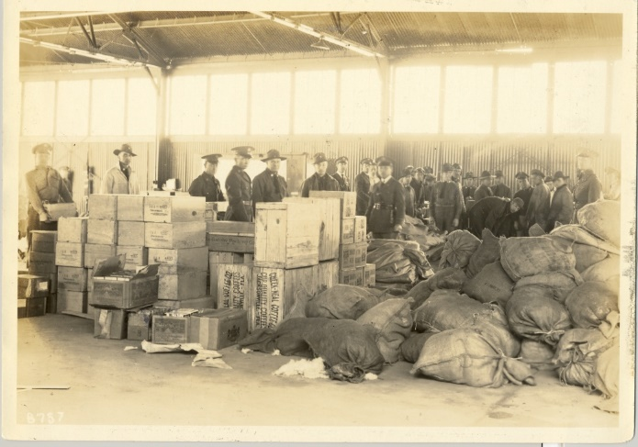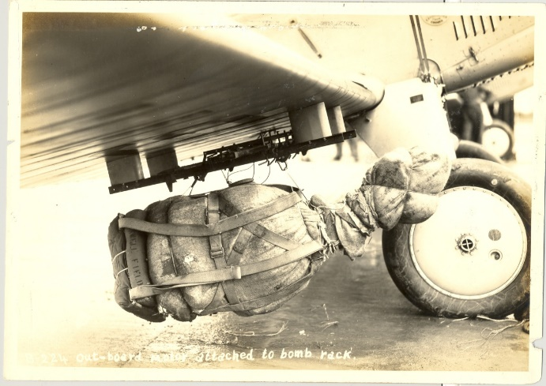

Maxwell Continues To Respond

Hurricane Ivan

In September 2004 Maxwell AFB was declared a Base Support Installation (BSI) for FEMA post- Hurricane Ivan disaster relief operations. FEMA staged semi-truck operations on the Assault Strip. The latter was closed with minimal effect on 90S1 ARW flying operations. Approximately 400 semi-trucks per day arrived/departed MAFB. By September 21 1263 trucks had been received and 798 trucks distributed (Figures VI-25 through VI-27). FEMA's self-contained nature resulted in a minimal impact on Maxwell daily operations.

The 42 ABW teamed up with 908 AW Aerial Port personnel to establish a small scale aerial port of debarkation to receive Class I relief supplies that arrived on C-130s. Additionally FEMA contracted for 3 Bell 206 Helicopters for rapid movement of small loads of Class I relief supplies to remote areas affected by hurricane Ivan. Finally, Maxwell provided bed down for a Forest Service Incident Management Team in the old 54 ALF workspace on the second floor of Base Operations.

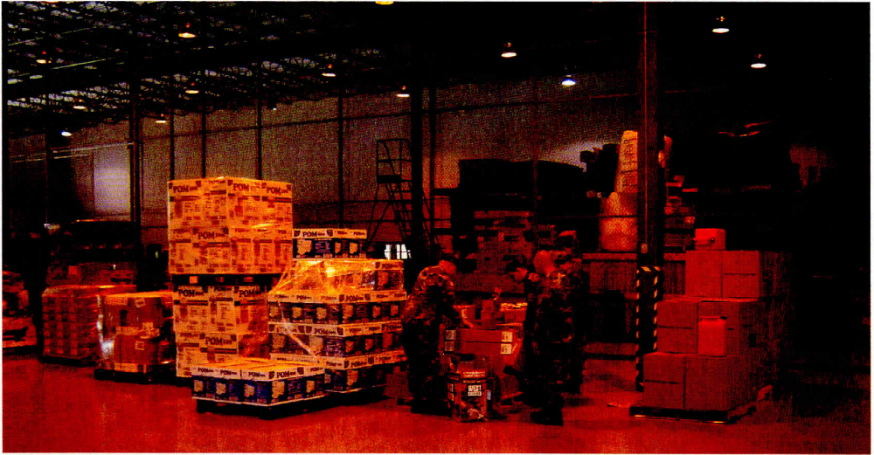
Supplies for Hurricane Ivan Victims

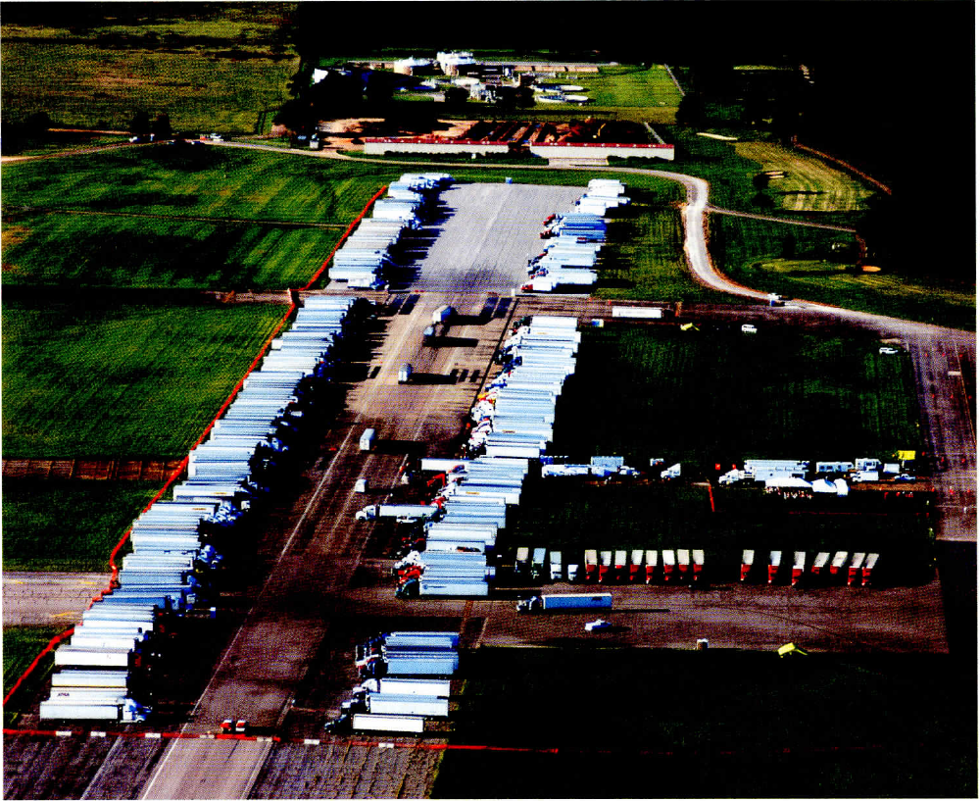
FEMA Truck Staging Area Maxwell AFB

Hurricane Dennis

In July 2005 Maxwell faced a threat to its people and resources from Hurricane Dennis which had formed on 5 July in the eastern Caribbean and intensified into a Category 4 hurricane, the strongest ever recorded in July, with a pressure of 930 mbar. It ultimately made landfall as a category 3 Hurricane, on the Florida Panhandle, at Santa Rosa Island, between Pensacola, Florida, and Navarre Beach, at 2:25 p.m. CDT (1925 Zulu) on 10 July 2005. Maxwell provided shelter for evacuees from lower Alabama and affected areas in Florida.

Among those seeking shelter for military personnel were the US Coast Guard which sought to relocate 400 families and pets; Eglin AFB and Hurlburt Field; and Aviation Training Center - Mobile, looking to evacuate 15 aircraft and 56 crew members. Additionally, FEMA required lodging for 25 -to 30 Personnel from the Forest Service Incident Management Team, Beyond this, there was the need for logistical support. FEMA requested space for around 10 Tractor Trailers used to transport water; 10 Tractor Trailers transporting ice; and 5 tractor Trailers transporting MREs. The Army Corps of Engineers also requested space to bed down four Tractor Trailers, two RVs (C2), a Fuel truck pulling generator set, and nine F250/F350 pick up trucks.

There was a concern about how much the base could provide by way of shelter for families and pets; airfield ramp and hangar space; dining facilities; lodging, medical support. In addition security questions needed to be addressed, priority for people coming in needed to be established, and the impact of all of this on the installation and its mission needed to be considered. Operating on "Lessons Learned" during Hurricane Ivan, a number of recommended actions were made to deal with some of the issues confronting the base. Among these were to open up the CAP hangar for FEMA staging by parking CAP aircraft in the Aeroclub hangar, to begin Shelter Management Actions, set up a reception center, authorize SVS and to provide meals to ADVON teams. Command Post also suggested that it be relocated to an alternate CAT site for operations purposes, to establish workgroup reception, and to appoint a POC for FEMA.

The following day, July 8, Maxwell-Gunter personnel were instructed to begin to take steps to minimize the threat personnel and resources. Included with the announcement was a list of things to do and actions to take to prepare for potential disruption in services caused by power outages. There was also an update on shelter status, pointing out that space for a total of 1,625 personnel was available at various locations throughout the base. Command personnel pointed out that storm track projections indicated that the Maxwell-Gunter area could begin to experience hurricane effects in the form of high winds and rain as early as 1500 Sunday, 15 September and that Maxwell AFB and Gunter Annex were in HURCON 4 which meant that 50 knot winds were possible within 72 hours. The storm was classified as a category 4 Hurricane with gusts of 161mph moving NW at 16 mph.

At 0700 on 9 July the Crisis Action team stood up and held their morning meeting. At the time Maxwell-Gunter was in HURCON 3 with winds exceeding 50 knots expected within 48 hours. The storm, then located over the western Florida Keys, had weakened a great deal more than expected as it crossed Cuba. Though, the expectation was that Dennis would reintensify to category 3 as it moved across the Gulf of Mexico. Landfall was still predicted to occur Sunday afternoon (10 July), with a forecasted intensity of 115 mph, in an area just west of Pensacola.
Still, the possibility existed that Dennis could make landfall anywhere between eastern Louisiana and the panhandle of Florida. There were also warnings and watches issued by the National Weather Service for the Maxwell-Gunter area. These included an inland tropical storm watch from Sunday afternoon until Monday morning, and a flash flood watch from Sunday afternoon until Monday morning. Southern Alabama, including the Maxwell-Gunter area was advised to expect "possible" significant river flooding.

At the 1700 briefing on 9 July the Maxwell Crisis Team announced that the Base was
under HURCONE I as of 0900 local time and that:

• ABW UCCs stand up at 0700L
• River Road gates were closed
• The Dining Hall was to close at 1200L
• Expect restriction to quarters 1300L
• Gov Riley declared state of emergency 8 Jul
• USCG boats and other equipment into ISO hanger
• All aircraft were hangared
• 187th FW F-16s (4) in 908th hangar
• Shelter truck with Satellite in Bldg 843
• FEMA Supported by IMT (Bldg 844) and Corps of Engineers Trucks began arriving Saturday PM
- EXORD received Gate 8 Open

The Command Center noted that FEMA had requested a Generator via 12 FTW MAFB made two 60 kw and one 15 kw mobile, diesel generator assets available to FEMA. These generators were in an operational state due to Hurricane Ivan preparation. By this time the FEMA marshalling area had been well-defined with a combination of snow fence, and ropes with the signage still being worked. Though in the ensuing hours Dennis grew into a category IV Hurricane, once again putting Maxwell-Gunter on HURCON 2 alert. Landfall was predicted to occur near Mobile, Al. around 1600, Sunday, 10 July with forecasted wind speed at landfall 120 knots (138 mph).

As noted earlier Dennis made landfall as a category 3 Hurricane, on the Florida Panhandle, at Santa Rosa Island, between Pensacola, Florida, and Navarre Beach, at 2:25 p.m. on 10 July (Figure VI-32). The storm advisory for Maxwell-Gunter was again downgraded to HURCON 1 with a possibility of 50 knot winds within 12 hours. FEMA reported that:

• Trucks began arriving Saturday PM
• Trucks on station 105; Trucks Enroute 40-50 from ATL
• Support Personnel on site (other IMT personnel inbound)
• Recovery status
• FEMA ops ongoing - constant vigilance/eyes on required by 42
ABW/FEMA Liaisons and Airfield Management personnel

Hurricane Katrina

This extraordinarily powerful and deadly hurricane, was also one of the deadliest hurricanes and most devastating natural disasters in the history of the United States. It was the sixth-strongest ever recorded and the third-strongest land falling U.S. hurricane on record. Katrina formed over the Bahamas on 23 August 2005 and made its first landfall on 25 August at 22:30 at the Broward/Miami-Dade County line, crossing southern Florida as a Category 1 hurricane. As it passed over Florida the storm weakened considerably, though it gained considerable strength in the Gulf of Mexico, becoming one of the strongest hurricanes on record. On the morning of 29 August 2005 Katrina, then a Category 3 storm, made a second landfall at 11:10 near Buras, Louisiana, and a third landfall at 14:45 near the Louisiana/Mississippi state line.

During previous hurricanes personnel from sister installations had requested "safe heaven" at Maxwell. To prepare for this contingency Maxwell Support Group personnel were instructed to review the sheltering plan, specifically, to determine the number of billeting rooms available on and off base, to determine alternate sheltering facilities, to plan for housing families and pets, and to allow for ERC activation time. On base readiness called for an evaluation of airfield ramp and hangar space, a review of the 908th aircraft evacuation and sheltering plan, the Blue Thunder teardown plan. Finally, planning efforts included a contracting site sweep, sandbagging efforts, and procedures for evacuating family camp. At the same time the Command Center recommended to make the ISO hanger available to FEMA as an operating location, and to make building 1154 available for AEMA. As the day progressed the initial evacuation requests were received by Maxwell CAT personnel. The first requests were received from Eglin AFB, looking for accommodations for ADVON of 4 plus 200 emergency response personnel. A second request came from Hurlburt Field seeking facilities for a 9 man Logistics support team for AFSOC.

By 29 August Katrina had strengthened to a Cat 4 Hurricane and was located approximately 60 miles south-southeast of New Orleans. Hurricane warnings were issued for the eastern half of the Louisiana coast, Mississippi coast, and Alabama coast. the National Weather Service stated that Hurricane Katrina would make landfall 50 miles southeast of New Orleans with winds of 130 gusting to 160 knots, that it would continue to move due north over the ensuing six hours, weaken and progress into Mississippi and Tennessee. While Maxwell-Gunter were not in the direct path of the storm the facility, was nevertheless subject to peripheral winds. Indeed, personnel were cautioned that conditions were subject to change and that the upcoming 48 to 72 hour positions contained a high degree of uncertainty.

Efforts to protect the base and its assets were initiated as the storm advanced inland. Maxwell also received lodging assistance/ bed down requests from DoD installations in the path of the storm. This placed a great demand on physical resources as well as support services on base. Evacuees who could not be accommodated on Maxwell proper were placed either at Gunter Annex or in private homes in the surrounding area. During the relief effort Maxwell supported a total of more than 1072 evacuees and 104 pets. The earliest arrivals were the 85 members and dependents of the 313 Training Squadron, Corey Naval Air Station. These were followed by the arrival of 97 Keesler NCO Academy attendees and staff members 31 August and 1 September. Evacuees required, reception, care, and feeding. Moreover, the Keesler NCO Academy requested facilities to be able to complete the training of its attendees. At 1930 on 1 September 40 Keesler international students and 25 family members arrived at Maxwell by C-130. They too, required lodging, food, ticketing, and transportation and preparation for their return to their home countries. Be that as it may, there were a limited number of rooms available for evacuees which meant that alternative billeting arrangements had to be made for these arrivals and their pets. In other words hangar space, gymnasium facilities and other non-billeting space had to be converted to temporary lodging. As it stood, the following space was available at the time Katrina made landfall:

BLDG | Description | Current #'s
841 | Fitness Center | 350 4 Pets
1 | Youth Center | 250
1154 | Base Supply | 250
 | Community Activity Ctr | 75
538 | Elementary School (construction  limiting #?) | 350
155 | Chapel 2 (leak in basement) | 90
1425 | Ritchey Center | 75
800 | GUNTER Fitness Center | 110
863 | Youth Center | 75

CAT personnel had a fairly good idea about the number and location of evacuees present in the area, but found it difficult to maintain accurate numbers because some individuals failed to follow proper checkout procedures when they departed. It was noted earlier that Maxwell supported a total of more than 1072 evacuees and 104 pets, though, as evidenced by Table VI-9, the total number of evacuees in the Maxwell-Gunter area at any given time never exceeded 979. There were a number of departures, as evidenced by Table VI-10 beginning 3 September, though, modest numbers of evacuees continued to arrive. Finding adequate lodging, then, did not prove to be problem some had anticipated. The number of animals expected peaked at 104 with the arrival of 45 pets from Keesler on 3 September necessitating their movement from the Gym to the Aeroclub hangar (supported by Vet Tech). Though by the time the move was undertaken the number of pets in the gym had declined to 70.

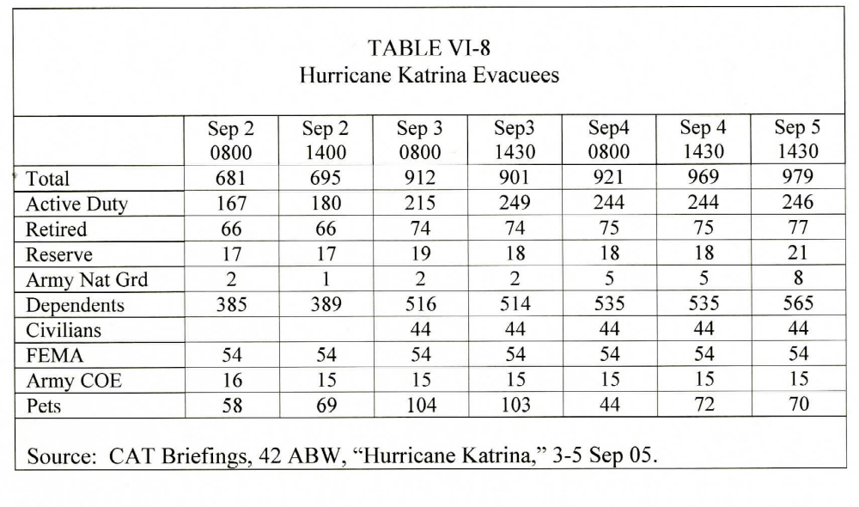

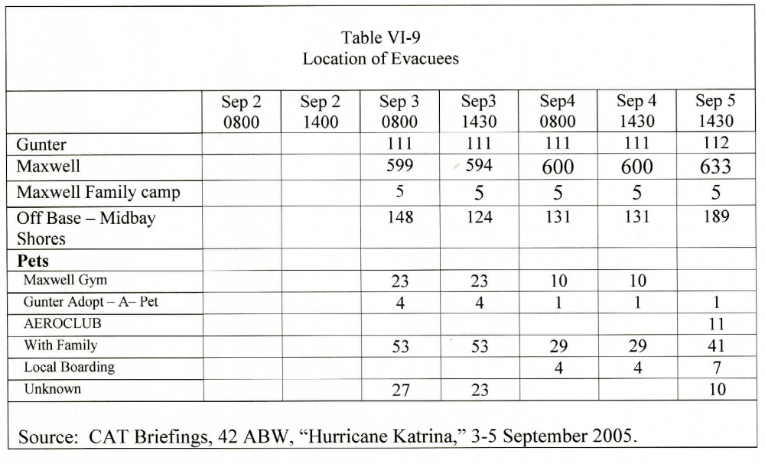

Other bed down requests came from the U.S. Army Corps of Engineers, the Alabama Emergency Management Agency (AEMA), FEMA, and the Armed Forces Veterans Hospital. The first of these was received on 27 August from the U.S. Army Corps of Engineers, which worked out of the base COE office. The following day, 28 August, the AEMA activated the AL MOB center 1500-1600L, and anticipated bringing 13 trucks on Sunday, 31 August, to preposition for storm relief. Consequently 50 rooms were blocked for AEMA support personnel. Maxwell, as noted earlier, served as a Federal Operational Staging area. FEMA reported that 125 trucks to support Alabama relief had been requested, that these were due to arrive Mon 29 August, and that billeting and food for nearly 230 personnel would be required. Moreover, it was anticipated that there could be as many as 120 inbound trucks a day. Ultimately FEMA processed in excess of 1289 truckloads of commodities (see Table VI-11). On 31 August the Veterans Hospital requested that Maxwell temporarily receive and feed 58 senior veterans, and to help process them for aerovac to Andrews AFB. Of these 56 senior veterans were aerovaced to Andrews on 31 Aug and 1 September accompanied by 2 Maxwell hospital personnel traveled with. The remainder were placed in a Montgomery hospital.

Bed down was also provided for Army and Army National Guard units enroute to and from relief operations in Mississippi and Louisiana. Among these was the 5th Combat Communications Group from Ft. Gordon, Ga. which arrived on 4 and 5 September with 33 personnel 6 PAK and 5 Deuce-and-a-half trucks. Maxwell supported this unit with lodging, rations and gas for the vehicles. Maxwell also provided assistance to the 192 AW ANG (Reno, Nevada) forward to NAS New Orleans and to recover at MAXF for night imagery missions. Involved was support for a period of two weeks for one C-130, and ten personnel. Billeting was arranged by the base and support coordinated by the 908th. Then, Maxwell served as a convoy refuel/rest point for the 1654 AW with its 27 vehicles and 96 personnel. Finally, on 17 September, Maxwell provided lodging for 700 personnel and fuel for 200 vehicles, including tractor trailers, HUMVEES and deuce-an-a-half trucks of the Georgia Army National Guard. Personnel were billeted in the ISO hanger on cots. Shower facilities were provided by the Fitness Center with additional, though, limited shower/restroom facilities available within the ISO hangar. Food was provided at the Riverside Dining Facility on the 16* and 17*, payment for meals were picked up by the AF via DOD Subsistence in Kind funds. Maxwell Security Force personnel coordinated with the Montgomery Police Department for off base traffic control on Saturday 17 September to facilitate the departure of the ANG from the area.

Maxwell provided a good deal of support during Hurricane Katrina not only in terms of offering shelter and on base services for evacuees but also, as noted previously, as a staging area from which FEMA could mount its relief efforts. Maxwell provided a good deal of support to FEMA and other organizations as they sought to provide the needed relief. On 2 September, for example, the Fuel Depot honored a request to provide 1600 gal. regular, 600 gal. diesel for Red Cross Vehicles. Also on 2 September the base shipped 10 million MREs to Mississippi. Though, not all requests could receive favorable consideration as in the case of the Red Cross seeking 1 million sq feet space on base to store supplies, something the base could not provide.

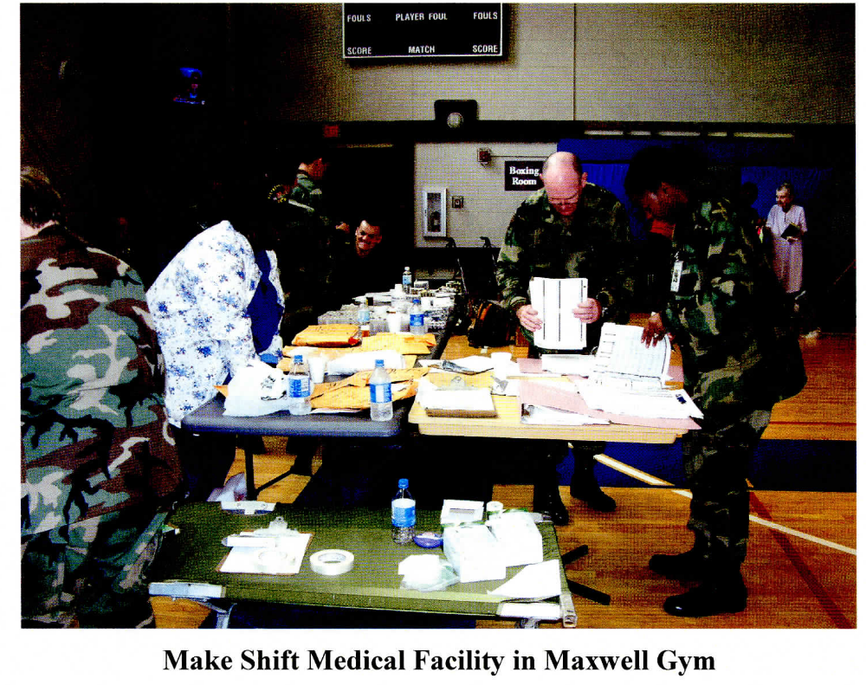
Maxwell also provided on-site support at Keesler AFB. On 31 August, for example, Maxwell provided Generator support sending 4 Generators to Keesler via flatbed. In addition Maxwell deployed one Public Affairs person to assist Keesler Public Affairs, 13 Security Forces Personnel to assist with security at the base(remained for 60 days), a civilian personnel team led by Dennis Paquette, and 42 MSS personnel to service Keesler personnel on MPF issues. Finally, Maxwell was tasked with tracking individuals coming in from other bases who forward deployed to affected areas.
AFCS  PA | UNIT  FGO NY | ORI  1 SEP 05
PA | FGO Kirtland | 1 SEP 05
PA | FGO Wright-Patterson | 1 SEP 05
PA | FGO Eglin | 1 SEP 05
PA | CGO Tyndall | 1 SEP 05
PA | CGO Vance | 1 SEP 05
PA | CGOEglin | 1 SEP 05
PA | CGO Sheppard | 1 SEP 05
PACraftsman | Langley | 1 SEP 05
PA Craftsman | Patrick | 1 SEP 05
PA Craftsman | Fairchild | 1 SEP 05
PA Craftsman | Peterson | 1 SEP 05
2 Combat | Charleston | 1 SEP 05
Combat | Macdill | 1 SEP 05

Hurricane Isaac

In late August 2012, Maxwell AFB again served as a staging area for FEMA relief supplies as Hurricane Isaac approached the coasts of Louisiana and Mississippi, seven years to the day after Hurricane Katrina devastated this part of the Gulf Coast. The hurricane, downgraded to a tropical storm by that afternoon, drenched the coastal areas with more than a foot of rain and flooded many low-lying areas. The upgraded $14.5 billion flood protection system around New Orleans held, and the majority of the city’s residents did not evacuate. Although more than 4,000 people evacuated to shelters across Louisiana, there were no fatalities. Between 26 and 31 August, 306 FEMA trucks with water, food, medical equipment, blankets, cots and large generators arrived at the Maxwell staging area from all over the country. More than 200 people from FEMA and the US Army Corps of Engineers also came to Maxwell to provide 24-hour coverage as the storm approached. In addition to providing the staging area for the FEMA trucks, 42 ABW also made its lodging facilities available for possible evacuees from the Gulf Coast, according to Col Trent Edwards, the 42 ABW commander.

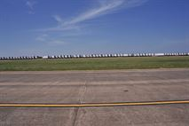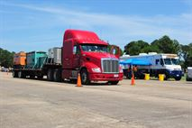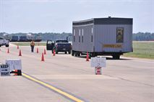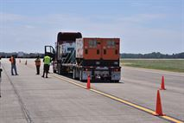
Maxwell Air Force Base hosts Federal Emergency Management Agency trucks waiting to assist areas in the Southeast effected by Tropical Storm Isaac, Aug. 27. Beginning Saturday, more than 120 semi-trucks filled with water, food, medical equipment, blankets, cots and generators big enough for hospitals began flowing into the base. (U.S. Air Force photo by Master Sgt. Michael Voss)

PrattvilleTornado
February 2008

On Sunday 17 Feb 2008, at 1440 local time, a super cell thunderstorm capable of producing tornadoes moved into northeastern Lowndes County approximately 10 miles west of Maxwell AFB. Base weather personnel noticed rotation in the storm which indicated that a tornado was in the process of occurring or about to occur. Base weather quickly issued a tornado warning for Maxwell AFB at 1443, and the Command Post set-off the base sirens. At 1503, Maxwell Tower personnel and the duty forecaster saw a tornado touching down approximately four to five miles northwest of the base, which, they stated, popped back up into the cloud. Airfield Tower personnel then evacuated the building. The tornado touched down again shortly afterwards in the city of Prattville. At 1900 on Sunday, the City of Prattville issued a dusk to dawn curfew, at 20:08, all activities, with the exception of the crews who worked on downed power lines throughout the night, were placed on hold, approximately four to five miles northwest of the base, which, they stated, popped back up into the cloud. Airfield Tower personnel then evacuated the building. The tornado touched down again shortly afterwards in the city of Prattville. At 1900 on Sunday, the City of Prattville issued a dusk to dawn curfew, at 20:08, all activities, with the exception of the crews who worked on downed power lines throughout the night, were placed on hold.

Prattville Tornado
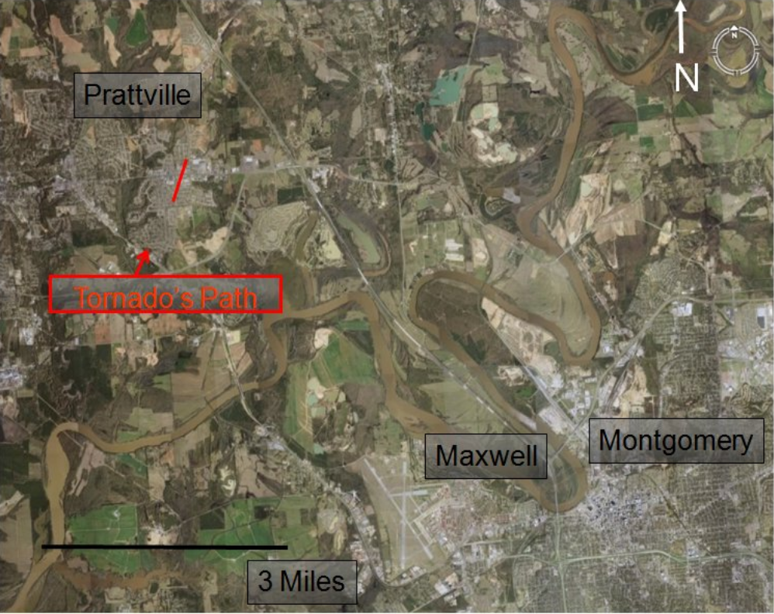

Timeline for Maxwell AFB response

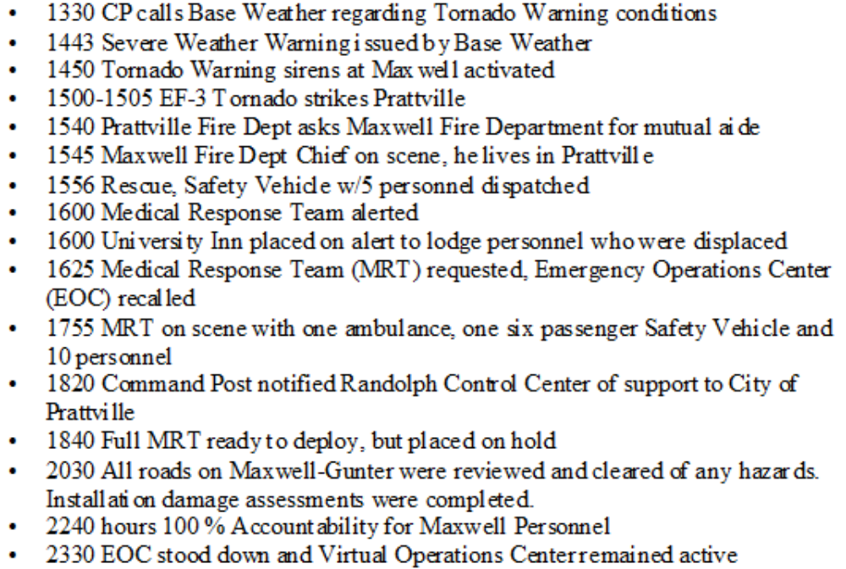

Prattville City, Autauga County Emergency Management Agency, Alabama Emergency Management Agency and Federal Emergency Management Agency took full control of the disaster. Local Volunteer Organizations Assisting Disasters (VOAD), Local Community Emergency Response Team (CERT), American Red Cross, Salvation Army, and volunteers from Maxwell AFB and the Civil Air Patrol also responded to the city.

The National Weather Service declared that an EF-3 tornado that touched down in Prattville, Al. The tornado damaged over 864 homes, 45 of which belonged to Air force members, and about 200 local businesses. The tornado also totally destroyed approximately 155 homes including those of nine Air Force members, and displaced 600 families. Eighteen families were temporarily relocated to on-base lodging, and ten families were relocated to base housing. One AWC faculty member was hospitalized with lacerations and fractured vertebrae suffered during the tornado (released from hospital on 27 Feb 2008). A total of 50 people were injured during this disaster. The cleanup effort took more than two months while the rebuilding effort required a great deal longer, in some cases nearly a year.

Maxwell leaders noted that a strong relationship existed with the Prattville community. Maxwell officials prepared for disaster relief operations within 24 hours of the tornado touching down. First, a Military Liaison Officer was embedded with the Autauga County/Prattville Emergency Management Agency for three days, starting on 18 Feb 2008. At the same time, plans were underway to care for and feed displaced DoD personnel, and Maxwell-Gunter senior leadership conducted the first of two site visits.

While the site was not deemed a Federal Disaster Area, the severe weather with tornado damage in the local area met the requirements in AFI 10-2501, Air Force Emergency Management (EM) Planning and Operation, and AETCI 10-205, AETC Exercise Program, for Severe Weather Response, Natural Disaster Response, and Base Recall. Accordingly, Maxwell deployed disaster teams to Prattville on 19 and 20 February. Approximately 340 military members volunteered to support the local community through the Volunteer Organizations Active in Disaster (VOAD) to help city debris teams remove debris from city streets in order to allow emergency crews, such as power crews, cable, and phone crews, to restore needed utilities. Using the $15.15 per hour Alabama standard for volunteer debris work, the base saved the city approximately $34,000 in labor costs.

AU and 42ABW personnel provided immediate assistance to military members/affected families and community Sunday throughout the ensuing week. On 19 and 20 February, the 42 ABW held Town Hall meetings and made medical, legal, housing, Air Force Aid support available to government families affected by the tornados. Family Readiness, Services, AAFES, Defense Commissary Agency, and others participated. Pinnacle-Hunt, the base housing contractor, responded within hours and moved families on-base within 18 hours of the event. Another success story was the local, state, and national media response. The local response utilized TV and radio and included recall instructions, and dining availability on base (military only).

Tornados
25 -28 Apr 2011

Maxwell AFB served as the staging area for relief supplies provided by the Federal Emergency Management Agency (FEMA) in the wake of several regional natural disasters. During the period 25-28 Apr 2011, northern Mississippi, northern Alabama, central Tennessee, western North Carolina, Virginia, and Georgia experienced at least 388 tornadoes, the greatest outbreak of tornadoes since 1932. This record-breaking outbreak of tornadoes resulted in 321 deaths in the affected states and caused an estimated $9 billion in damage. On 27 April, starting before sunrise and lasting until nearly 2200, 62 tornadoes, including two EF-5 tornadoes, struck 35 of 67 Alabama counties, killing 248 people, injuring another 2,219, and destroying or damaging 23,553 homes. At 1643, an EF-4 tornado hit Tuscaloosa, Alabama, and destroyed two sections of the city. It killed 43 people, injured about 1,200 people, caused about $2 billion in damage, and left much of the city without power for over a week. On 29 April, President Barack Obama visited the devastated area of Tuscaloosa and remarked that he had “never seen devastation like this.” At 2012, another EF4 tornado cut a half-mile swath of destruction for 44 miles across Elmore and Tallapoosa Counties, caused severe damage Maxwell’s recreational facility at Lake Martin, and killed four people. By 3 May, the Alabama CAP Wing alone had flown 23 sorties for a total of 33 hours of flight time and took more than 2,000 aerial photographs of the areas of Alabama devastated by the tornados.

In response to this far-reaching disaster, Maxwell AFB opened its FEMA staging area within 16 hours after FEMA received the call to respond. The area received 601 semi-trucks and vehicles from FEMA and the US Army Corps of Engineers, containing tarps, food, water, medical supplies, generators, and other relief equipment and supplies for tornado victims in Alabama. In addition, various base agencies and organizations provided donations to the tornado survivors. “The base community would like to send its condolences to all those throughout the state who are suffering right now,” said Col Brian Killough, the 42ABW commander. “We are humbled to do what we can to help Alabama citizens, and we are prepared to help with the federal government’s relief efforts.” FEMA began closing this operation at the end of May.

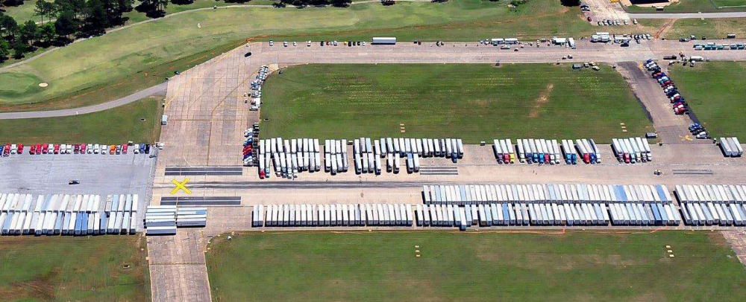
This photo shows an aerial view of the Federal Emergency Management Agency (FEMA) staging area, located on the far side of the Maxwell Air Force Base runways with trucks loaded with disaster relief supplies for people in northern Alabama, following the outbreak of over 300 tornadoes across northern Mississippi, Alabama, and Georgia, 25-28 April 2011.

Louisiana Flood Relief
26 August – 8 Sep 2016

Once again Maxwell AFB served as the logistical operational support center for FEMA to receive, stage and distribute trailers of commodities at the ISB location in support FEMA's Incident Support Base Operations at Maxwell AFB, AL. FEMA began initial staging operations at Maxwell AFB on Friday 26 Aug 2016 at approximately 1800Z/1300L and began staging approximately 150 contractor trucks on 27 Aug 2016. Airfield Operations, Security Forces (SFS), and Civil Engineering worked together to prepare the airfield for FEMA arrival:

Barriers were placed at key intersections; procedures for hangar access on taxiways were coordinated with 908 ARW, FEMA, and SFS. FEMA trucks being processed at this time. A notice to Airmen was issued regarding FEMA activity. CAP USAF aircraft were repositioned to spot 11 on West Apron. Free Zone in staffing for FEMA and CAP USAF on west side in restricted area. Waiver for fire hydrant wingtip clearance chopped by A3 functional and good to go. Will staff this airfield waiver package from CE for expeditious coordination and signature with forwarding to MAJCOM for ultimate approval.

12 portable latrines and two 8-yard dumpsters were requested by FEMA and have been delivered and placed as requested. Estimated cost, using existing contract vehicle in place, is $750 for first month; $720/month thereafter.

Security Forces provided 3 additional personnel for access control at the entry point to the installation as well as traffic control. Staging operations began at 1300 today and will end at 2000. Gates open at 0700 and close at 2000 Saturday & Sunday.

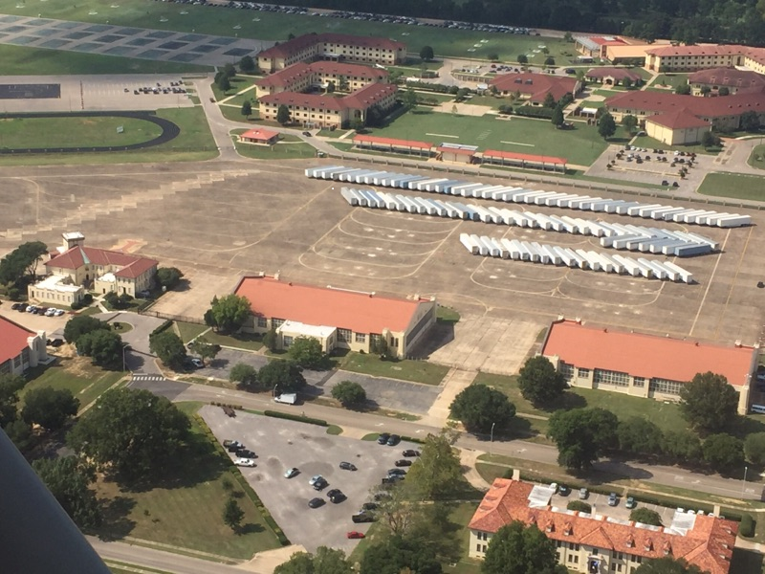

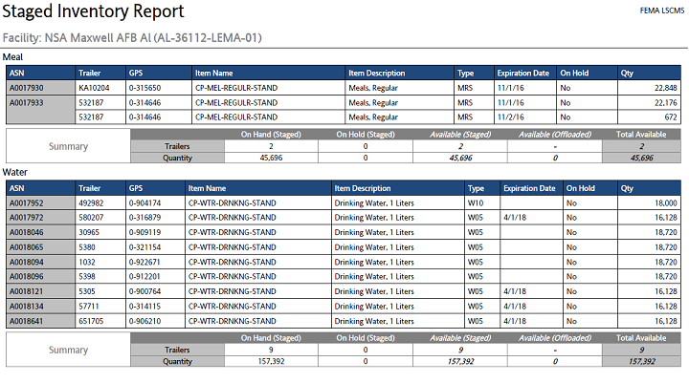

42OSS in coordination with 908AW (AFRC) developed plans for being able to concurrently accept FEMA support and Alabama Emergency Management Agency (ALEMA) logistics on the MAFB ramp, even in light of runway construction. Mission essential local flying operations not affected at this time. 42OSS continues to evaluate all requests for transient flying operations on a case by case bases in coordination with 42CONS and 42CE and to the maximum extent possible accommodated those requests.

FEMA continued ISB operations at Maxwell AFB until 9 Sep 2016. REMA retrograde commenced 4 Sep 16. By 6 September 42 outbound shipments had been processed, and retrograde was 60 percent complete. As of 6 September 65 Trailers were shipped from ISB with 45 Trailers remaining. At this point the ISB was manned by 12 Defense logistics Agency Personnel and 4 FEMA Personnel. FEMA completed retrograde operation on 7 Sep 16 and initiated ISB closure with Maxwell AFB on 8 Sep 2016. The service and cooperation FEMA received from Maxwell AFB greatly supported the DHS/FEMA response to Hurricane Hermine. It enabled FEMA to provide the necessary safety stock to the disaster issues affecting the citizens of, Florida, Georgia, South Carolina, and North Carolina. Please accept our thanks and appreciation.

Hurricane Irma
September 7 – September 18, 2017

On 30 August Tropical Storm Irma formed 42o miles west of the Cabo Verde Islands. The following day it intensified into a Category 3 hurricane. By September 5 it intensified into a “potentially catastrophic" Category 5 hurricane. Irma was on a direct path to Florida after it caused major damage to Antigua, Barbuda St. Martin, Anguilla, St. Kitts and Nevis, US Virgin Islands, British Virgin Islands, Dominican Republic, Turks, Caicos, Bahamas, Cuba, and Puerto Rico. On 10 September the Florida keys took a direct hit form Irma, now a Category 4 storm where 25 percent of the houses were destroyed an 65 percent sustained major damage. Irma next hit Marco island as a Category 3 storm and then went on to pummel Naples, Florida.

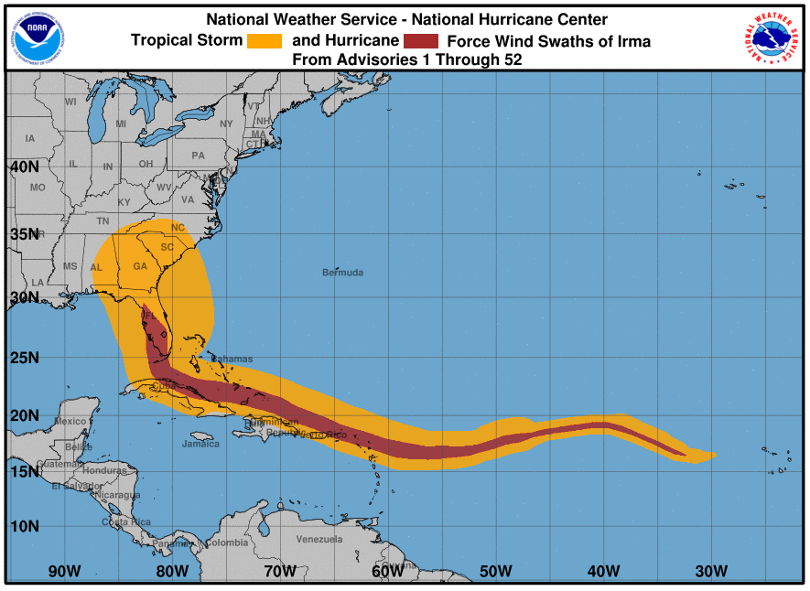
On September 6 Maxwell was notified that is was a Federal Emergency Management Agency Incident Support Base. Maxwell’s Emergency Operations Center activated on Sept. 7, 2017 and it, along with the Crisis Action team worked nearly around the clock to support the bed-down of emergency response personnel and equipment and displaced military members in response to Hurricane Irma. As Hurricane Irma races across the ocean, hundreds of tractor trailers carrying relief supplies raced to Maxwell to preposition for further disbursement. As part of this ISB role the wing was tasked with the reception and staging of 800 trucks full of relief supplies prepositioned to aid those impacted by Hurricane Irma. Nearly 200 trailers departed Maxwell for Florida, Sept. 12, 2007, to bring relief supplies to the state’s citizens.

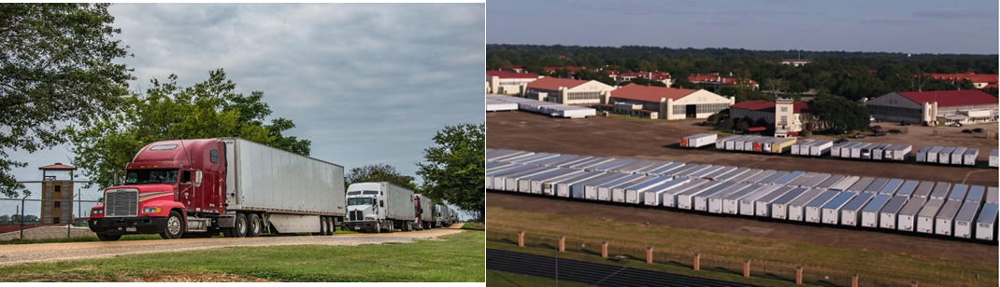

DLA Distribution DAILY SITREP DDXX Support to Hurricane Irma FEMA Region IV – 042
On 16 1700L OCT 17
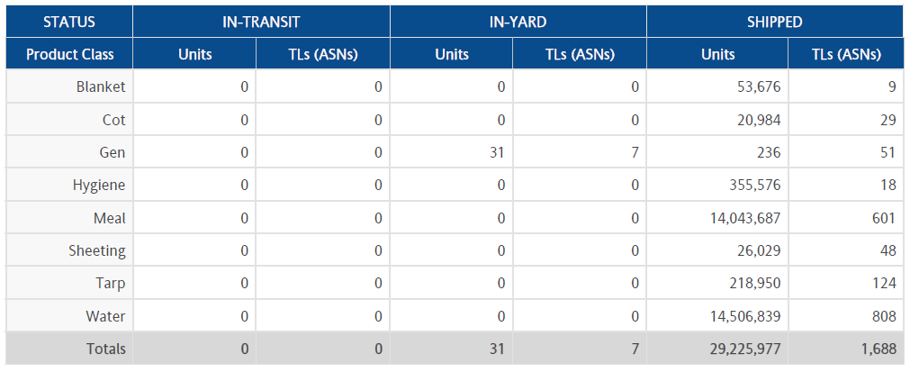

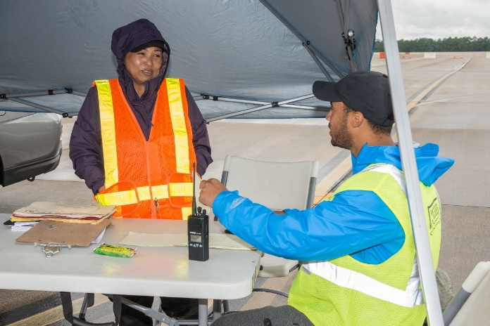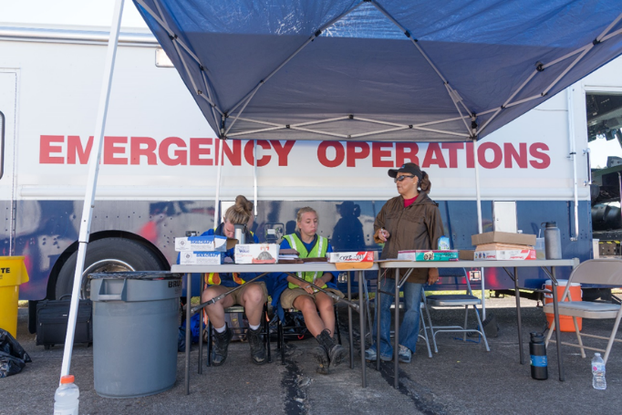

The base also hosted the Defense logistics Agency and also received numerous calls from military and civilian organizations looking at options for hurricane evacuation and potential mission roles in disaster relief, to include reception and bed down of personnel and aircraft. The Navy has a standing agreement with Maxwell AFB as an evacuation center. Military installations near or on the coast use Maxwell to divert from hurricanes because of its capacity and its location.

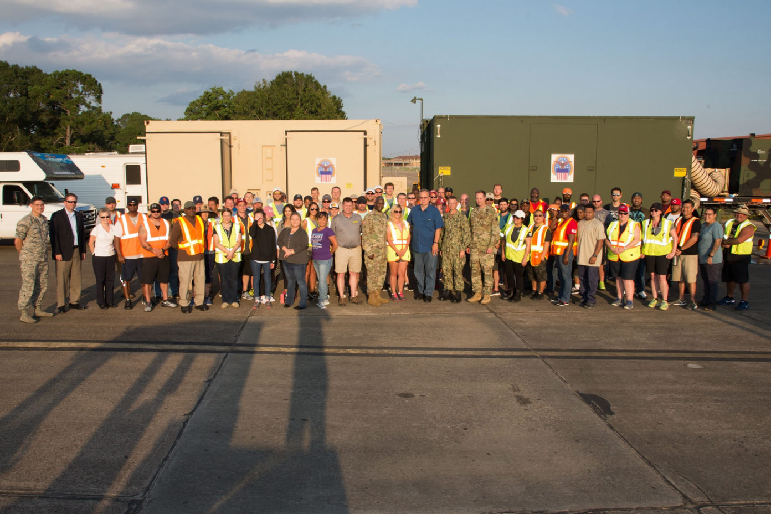
Lt. Gen. Darrell K. Williams, Director, Defense Logistics Agency with DLA and other support personnel from the Defense Logistics Agency, Fort Belvoir, Virginia at Maxwell Air Force Base
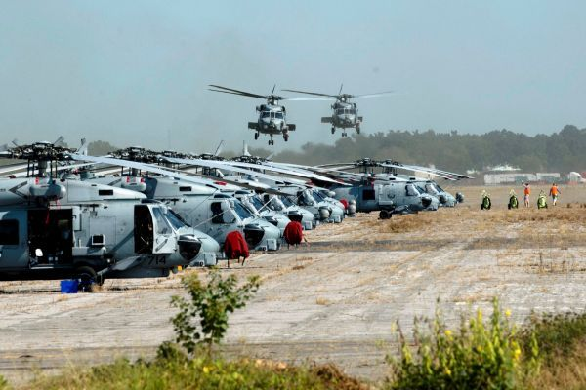

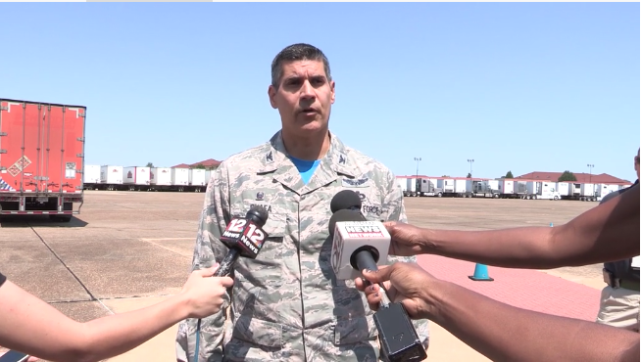
“First and foremost,” said Col. Eric Shafa, commander of the 42nd Air Base Wing, “our thoughts and prayers remain with those impacted by Hurricane Irma.” “I’m incredibly proud of how Team Maxwell has responded to this crisis,” he said. “While we never want disaster to strike, the wing trains and exercises constantly so that we are prepared to support the ISB mission, as well as the staging of any units for response and relief efforts.”

Ibid.

